**Experiment 9 28-03-2023**

**Aim : Shell scripting**

**Procedure**

**1.Shell Script to display the date**

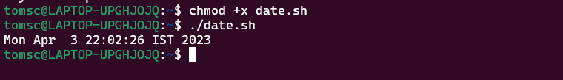

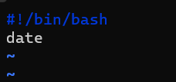

**2.Shell Script to display your name**

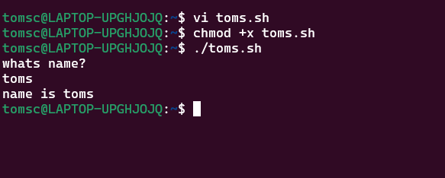

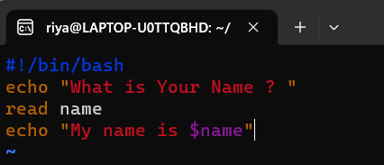

**3.Shell Script to display date , pwd , ls(multiple commands)**

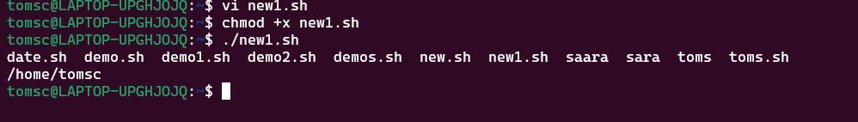

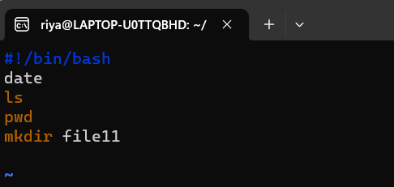

**4.Shell Script to demonstrate special variables**

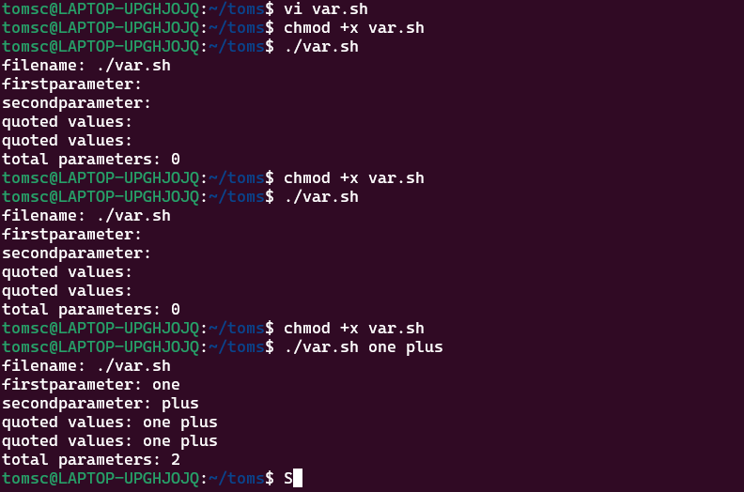

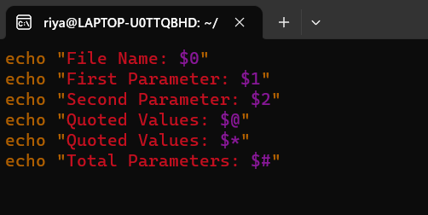

**5.Shell Script to count lines and words of the file**

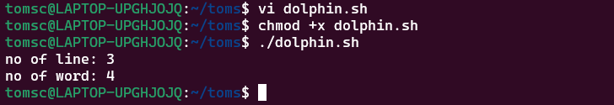

**6.Shell Script to display array index**



